*https://www.forcepoint.com/cyber-edu/osi-model#:~:text=The%20OSI%20Model%20(Open%20Systems,between%20different%20products%20and%20software.*

The OSI Model Defined

The OSI Model (Open Systems Interconnection Model) is a conceptual framework used to describe the functions of a networking system. The OSI model characterizes computing functions into a universal set of rules and requirements in order to support interoperability between different products and software. In the OSI reference model, the communications between a computing system are split into seven different abstraction layers: Physical, Data Link, Network, Transport, Session, Presentation, and Application.

Created at a time when network computing was in its infancy, the OSI was published in 1984 by the International Organization for Standardization (ISO). Though it does not always map directly to specific systems, the OSI Model is still used today as a means to describe Network Architecture.

**Benefits of the OSI Model**

Benefits of the OSI model include:

* Divides the aspects of network operations into less complex components.
* Standardizes interfaces, enabling engineers to specialize design and development efforts to specific functions.
* Facilitates modular engineering and prevents changes in one area from affecting others.
* Ensures interoperability and allows network designers to choose the right networking devices.
* Accelerates evolution and helps with testing and troubleshooting the network.

The first bullet refers to the fact that the OSI model divides networking concepts into seven hierarchical categories, the OSI layers. **Figure 1** illustrates the seven layers of the OSI model, which we explore next.

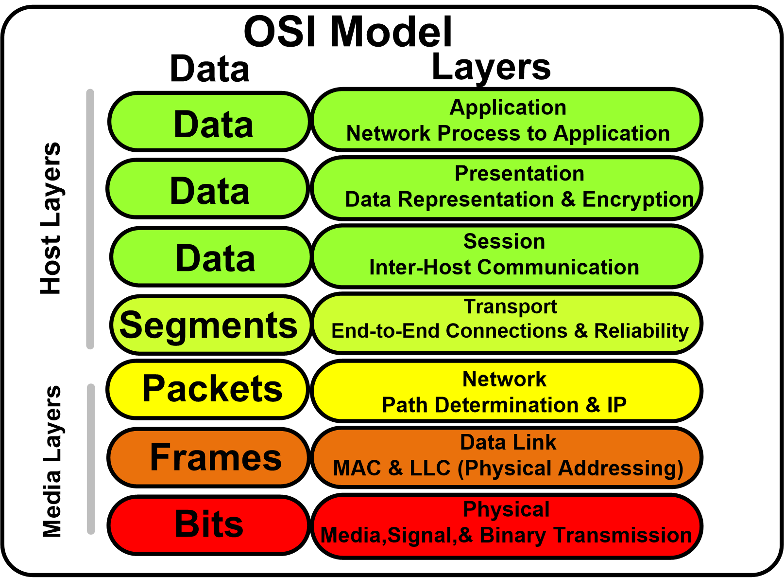

The 7 Layers of the OSI Model

Physical Layer

The lowest layer of the OSI Model is concerned with electrically or optically transmitting raw unstructured data bits across the network from the physical layer of the sending device to the physical layer of the receiving device. It can include specifications such as voltages, pin layout, cabling, and radio frequencies. At the physical layer, one might find “physical” resources such as network hubs, cabling, repeaters, network adapters or modems.

Data Link Layer

At the data link layer, directly connected nodes are used to perform node-to-node data transfer where data is packaged into frames. The data link layer also corrects errors that may have occurred at the physical layer.

The data link layer encompasses two sub-layers of its own. The first, media access control (MAC), provides flow control and multiplexing for device transmissions over a network. The second, the logical link control (LLC), provides flow and error control over the physical medium as well as identifies line protocols.

Network Layer

The network layer is responsible for receiving frames from the data link layer, and delivering them to their intended destinations among based on the addresses contained inside the frame. The network layer finds the destination by using logical addresses, such as IP (internet protocol). At this layer, routers are a crucial component used to quite literally route information where it needs to go between networks.

Transport Layer

The transport layer manages the delivery and error checking of data packets. It regulates the size, sequencing, and ultimately the transfer of data between systems and hosts. One of the most common examples of the transport layer is TCP or the Transmission Control Protocol.

Session Layer

The session layer controls the conversations between different computers. A session or connection between machines is set up, managed, and termined at layer 5. Session layer services also include authentication and reconnections.

Presentation Layer

The presentation layer formats or translates data for the application layer based on the syntax or semantics that the application accepts. Because of this, it at times also called the syntax layer. This layer can also handle the encryption and decryption required by the application layer.

Application Layer

At this layer, both the end user and the application layer interact directly with the software application. This layer sees network services provided to end-user applications such as a web browser or Office 365. The application layer identifies communication partners, resource availability, and synchronizes communication.

## https://www.cloudflare.com/en-in/learning/ddos/glossary/open-systems-interconnection-model-osi/

## What is the OSI model?

The Open Systems Interconnection (OSI) model is a conceptual model created by the International Organization for Standardization which enables diverse communication systems to communicate using standard protocols. On the other hand OSI provides a standard for different computer systems to be able to communicate with each other.

The OSI model can be seen as a universal language for computer networking. It’s based on the concept of splitting up a communication system into seven abstract layers, each one stacked upon the last.

Each layer of the OSI model handles a specific job and communicates with the layers above and below itself. [DDoS attacks](https://www.cloudflare.com/en-in/learning/ddos/what-is-a-ddos-attack) target specific layers of a network connection; [application layer attacks](https://www.cloudflare.com/en-in/learning/ddos/application-layer-ddos-attack) target [layer 7](https://www.cloudflare.com/en-in/learning/ddos/what-is-layer-7) and protocol layer attacks target layers 3 and 4.

## Why does the OSI model matter?

Although the modern Internet doesn’t strictly follow the OSI model (it more closely follows the simpler Internet protocol suite), the OSI model is still very useful for troubleshooting network problems. Whether it’s one person who can’t get their laptop on the Internet, or a web site being down for thousands of users, the OSI model can help to break down the problem and isolate the source of the trouble. If the problem can be narrowed down to one specific layer of the model, a lot of unnecessary work can be avoided.

## What are the seven layers of the OSI model?

The seven abstraction layers of the OSI model can be defined as follows, from top to bottom:

#### 7. The Application Layer

This is the only layer that directly interacts with data from the user. Software applications like web browsers and email clients rely on the application layer to initiate communications. But it should be made clear that client software applications are not part of the application layer; rather the application layer is responsible for the protocols and data manipulation that the software relies on to present meaningful data to the user. Application layer protocols include [HTTP](https://www.cloudflare.com/en-in/learning/ddos/glossary/hypertext-transfer-protocol-http) as well as SMTP (Simple Mail Transfer Protocol is one of the protocols that enables email communications).

#### 6. The Presentation Layer

This layer is primarily responsible for preparing data so that it can be used by the application layer; in other words, layer 6 makes the data presentable for applications to consume. The presentation layer is responsible for translation, encryption, and compression of data.

This layer can also handle the encryption and decryption required by the application layer.

Two communicating devices communicating may be using different encoding methods, so layer 6 is responsible for translating incoming data into a syntax that the application layer of the receiving device can understand.

If the devices are communicating over an encrypted connection, layer 6 is responsible for adding the encryption on the sender’s end as well as decoding the encryption on the receiver's end so that it can present the application layer with unencrypted, readable data.

Finally the presentation layer is also responsible for compressing data it receives from the application layer before delivering it to Session layer. This helps improve the speed and efficiency of communication by minimizing the amount of data that will be transferred.

#### 5. The Session Layer

This is the layer responsible for opening and closing communication between the two devices. The time between when the communication is opened and closed is known as the session. The session layer ensures that the session stays open long enough to transfer all the data being exchanged, and then promptly closes the session in order to avoid wasting resources.

The session layer also synchronizes data transfer with checkpoints. For example, if a 100 megabyte file is being transferred, the session layer could set a checkpoint every 5 megabytes. In the case of a disconnect or a crash after 52 megabytes have been transferred, the session could be resumed from the last checkpoint, meaning only 50 more megabytes of data need to be transferred. Without the checkpoints, the entire transfer would have to begin again from scratch.

#### 4. The Transport Layer

Transport layer responsible for end-to-end communication between the two devices. This includes taking data from the session layer and breaking it up into chunks called segments before sending it to Network layer. The transport layer on the receiving device is responsible for reassembling the segments into data the session layer can consume.

The transport layer is also responsible for flow control and error control. Flow control determines an optimal speed of transmission to ensure that a sender with a fast connection doesn’t overwhelm a receiver with a slow connection. The transport layer performs error control on the receiving end by ensuring that the data received is complete, and requesting a retransmission if it isn’t.

#### 3. The Network Layer

The network layer is responsible for facilitating data transfer between two different networks. If the two devices communicating are on the same network, then the network layer is unnecessary. The network layer breaks up segments from the transport layer into smaller units, called packets, on the sender’s device, and reassembling these packets on the receiving device. The network layer also finds the best physical path for the data to reach its destination; this is known as routing.

#### 2. The Data Link Layer

The data link helps data transfer between two devices on the SAME network. The data link layer takes packets from the network layer and breaks them into smaller pieces called frames. Like the network layer, the data link layer is also responsible for flow control and error control in intra-network communication.

#### 1. The Physical Layer

This layer includes the physical equipment involved in the data transfer, such as the cables and switches. This is also the layer where the data gets converted into a bit stream, which is a string of 1s and 0s. The physical layer of both devices must also agree on a signal convention so that the 1s can be distinguished from the 0s on both devices.

## How data flows through the OSI model

In order for human-readable information to be transferred over a network from one device to another, the data must travel down the seven layers of the OSI model on the sending device and then travel up the seven layers on the receiving end.

For example: Mr. Cooper wants to send Ms. Palmer an email. Mr. Cooper composes his message in an email application on his laptop and then hits ‘send’. His email application will pass his email message over to the application layer, which will pick a protocol (SMTP) and pass the data along to the presentation layer. The presentation layer will then compress the data and then it will hit the session layer, which will initialize the communication session.

The data will then hit the sender’s transportation layer where it will be segmented, then those segments will be broken up into packets at the network layer, which will be broken down even further into frames at the data link layer. The data link layer will then deliver those frames to the physical layer, which will convert the data into a bitstream of 1s and 0s and send it through a physical medium, such as a cable.

Once Ms. Palmer’s computer receives the bit stream through a physical medium (such as her wifi), the data will flow through the same series of layers on her device, but in the opposite order. First the physical layer will convert the bitstream from 1s and 0s into frames that get passed to the data link layer. The data link layer will then reassemble the frames into packets for the network layer. The network layer will then make segments out of the packets for the transport layer, which will reassemble the segments into one piece of data.

The data will then flow into the receiver's session layer, which will pass the data along to the presentation layer and then end the communication session. The presentation layer will then remove the compression and pass the raw data up to the application layer. The application layer will then feed the human-readable data along to Ms. Palmer’s email software, which will allow her to read Mr. Cooper’s email on her laptop screen.

<https://www.geeksforgeeks.org/layers-of-osi-model/>

<https://rufus.ie/en_US/>

**Layers of OSI Model**

OSI stands for **Open Systems Interconnection**. It has been developed by ISO – ‘**International Organization of Standardization**‘, in the year 1984. It is a 7 layer architecture with each layer having specific functionality to perform. All these 7 layers work collaboratively to transmit the data from one person to another across the globe.

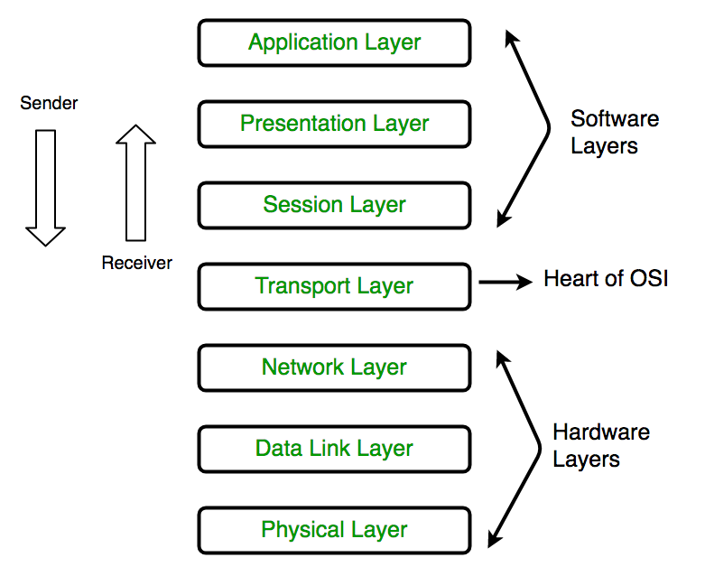

### **1. Physical Layer (Layer 1) :**

The lowest layer of the OSI reference model is the physical layer. It is responsible for the actual physical connection between the devices. The physical layer contains information in the form of**bits.** It is responsible for transmitting individual bits from one node to the next. When receiving data, this layer will get the signal received and convert it into 0s and 1s and send them to the Data Link layer, which will put the frame back together.

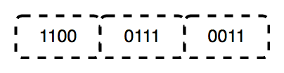

The functions of the physical layer are :

1. **Bit synchronization:** The physical layer provides the synchronization of the bits by providing a clock. This clock controls both sender and receiver thus providing synchronization at bit level.
2. **Bit rate control:** The Physical layer also defines the transmission rate i.e. the number of bits sent per second.
3. **Physical topologies:** Physical layer specifies the way in which the different, devices/nodes are arranged in a network i.e. bus, star or mesh topolgy.
4. **Transmission mode:** Physical layer also defines the way in which the data flows between the two connected devices. The various transmission modes possible are: Simplex, half-duplex and full-duplex.

* Hub, Repeater, Modem, Cables are Physical Layer devices.  
** Network Layer, Data Link Layer and Physical Layer are also known as **Lower Layers** or **Hardware Layers**.

### **2. Data Link Layer (DLL) (Layer 2) :**

The data link layer is responsible for the node to node delivery of the message. The main function of this layer is to make sure data transfer is error-free from one node to another, over the physical layer. When a packet arrives in a network, it is the responsibility of DLL to transmit it to the Host using its MAC address.  
Data Link Layer is divided into two sub layers :

1. Logical Link Control (LLC)
2. Media Access Control (MAC)

The packet received from Network layer is further divided into frames depending on the frame size of NIC(Network Interface Card). DLL also encapsulates Sender and Receiver’s MAC address in the header.

The Receiver’s MAC address is obtained by placing an ARP(Address Resolution Protocol) request onto the wire asking “Who has that IP address?” and the destination host will reply with its MAC address.

The functions of the data Link layer are :

1. **Framing:** Framing is a function of the data link layer. It provides a way for a sender to transmit a set of bits that are meaningful to the receiver. This can be accomplished by attaching special bit patterns to the beginning and end of the frame.
2. **Physical addressing:** After creating frames, Data link layer adds physical addresses (MAC address) of sender and/or receiver in the header of each frame.
3. **Error control:** Data link layer provides the mechanism of error control in which it detects and retransmits damaged or lost frames.
4. **Flow Control:** The data rate must be constant on both sides else the data may get corrupted thus , flow control coordinates that amount of data that can be sent before receiving acknowledgement.
5. **Access control:**When a single communication channel is shared by multiple devices, MAC sub-layer of data link layer helps to determine which device has control over the channel at a given time.

* Packet in Data Link layer is referred as ***Frame***.** Data Link layer is handled by the NIC (Network Interface Card) and device drivers of host machines.*** Switch & Bridge are Data Link Layer devices.

### **3. Network Layer (Layer 3) :**

Network layer works for the transmission of data from one host to the other located in different networks. It also takes care of packet routing i.e. selection of the shortest path to transmit the packet, from the number of routes available. The sender & receiver’s IP address are placed in the header by the network layer.  
The functions of the Network layer are:

1. **Routing:** The network layer protocols determine which route is suitable from source to destination. This function of network layer is known as routing.
2. **Logical Addressing:** In order to identify each device on internetwork uniquely, network layer defines an addressing scheme. The sender & receiver’s IP address are placed in the header by network layer. Such an address distinguishes each device uniquely and universally.

* Segment in Network layer is referred as **Packet**.  
** Network layer is implemented by networking devices such as routers.

### **4. Transport Layer (Layer 4) :**

Transport layer provides services to application layer and takes services from network layer. The data in the transport layer is referred to as Segments. It is responsible for the End to End Delivery of the complete message. The transport layer also provides the acknowledgement of the successful data transmission and re-transmits the data if an error is found.

**• At sender’s side:**

Transport layer receives the formatted data from the upper layers, performs **Segmentation** and also implements **Flow & Error control** to ensure proper data transmission. It also adds Source and Destination port number in its header and forwards the segmented data to the Network Layer.  
Note: The sender need to know the port number associated with the receiver’s application.

Generally, this destination port number is configured, either by default or manually. For example, when a web application makes a request to a web server, it typically uses port number 80, because this is the default port assigned to web applications. Many applications have default port assigned.

**• At receiver’s side:**

Transport Layer reads the port number from its header and forwards the Data which it has received to the respective application. It also performs sequencing and reassembling of the segmented data.

The functions of the transport layer are :

1. **Segmentation and Reassembly:** This layer accepts the message from the (session) layer , breaks the message into smaller units . Each of the segment produced has a header associated with it. The transport layer at the destination station reassembles the message.
2. **Service Point Addressing:** In order to deliver the message to correct process, transport layer header includes a type of address called service point address or port address. Thus by specifying this address, transport layer makes sure that the message is delivered to the correct process.

The services provided by the transport layer :

1. **Connection Oriented Service:** It is a three-phase process which include  
   – Connection Establishment  
   – Data Transfer  
   – Termination / disconnection  
   In this type of transmission, the receiving device sends an acknowledgement, back to the source after a packet or group of packet is received. This type of transmission is reliable and secure.
2. **Connection less service:** It is a one-phase process and includes Data Transfer. In this type of transmission, the receiver does not acknowledge receipt of a packet. This approach allows for much faster communication between devices. Connection-oriented service is more reliable than connectionless Service.

* Data in the Transport Layer is called as ***Segments***.** Transport layer is operated by the Operating System. It is a part of the OS and communicates with the Application Layer by making system calls.Transport Layer is called as ***Heart of OSI*** model.

### **5. Session Layer (Layer 5) :**

This layer is responsible for establishment of connection, maintenance of sessions, authentication and also ensures security.  
The functions of the session layer are :

1. **Session establishment, maintenance and termination:** The layer allows the two processes to establish, use and terminate a connection.
2. **Synchronization :** This layer allows a process to add checkpoints which are considered as synchronization points into the data. These synchronization point help to identify the error so that the data is re-synchronized properly, and ends of the messages are not cut prematurely and data loss is avoided.
3. **Dialog Controller :** The session layer allows two systems to start communication with each other in half-duplex or full-duplex.

**All the below 3 layers(including Session Layer) are integrated as a single layer in the TCP/IP model as “Application Layer”.**Implementation of these 3 layers is done by the network application itself. These are also known as ***Upper Layers*** or ***Software Layers***.

SCENARIO:  
Let’s consider a scenario where a user wants to send a message through some Messenger application running in his browser. The “Messenger” here acts as the application layer which provides the user with an interface to create the data. This message or so-called Data is compressed, encrypted (if any secure data) and converted into bits (0’s and 1’s) so that it can be transmitted.

### **6. Presentation Layer (Layer 6) :**

Presentation layer is also called the **Translation layer**.The data from the application layer is extracted here and manipulated as per the required format to transmit over the network.

The functions of the presentation layer are :

1. **Translation :** For example, ASCII to EBCDIC.
2. **Encryption/ Decryption :** Data encryption translates the data into another form or code. The encrypted data is known as the cipher text and the decrypted data is known as plain text. A key value is used for encrypting as well as decrypting data.
3. **Compression:** Reduces the number of bits that need to be transmitted on the network.

### **7. Application Layer (Layer 7) :**

At the very top of the OSI Reference Model stack of layers, we find Application layer which is implemented by the network applications. These applications produce the data, which has to be transferred over the network. This layer also serves as a window for the application services to access the network and for displaying the received information to the user.

Ex: Application – Browsers, Skype Messenger etc.

**Application Layer is also called as Desktop Layer.

The functions of the Application layer are :

1. Network Virtual Terminal
2. FTAM-File transfer access and management
3. Mail Services
4. Directory Services

OSI model acts as a reference model and is not implemented in the Internet because of its late invention. Current model being used is the TCP/IP model.

Data, Protocol & Activities

|  |  |  |
| --- | --- | --- |
| **OSI Layers** | **TCP/IP Suit** | **Activities** |
| Application | Application  Telnet, FTP, SMTP, HTTP, DNS, SNMP, Specific address etc. | To allow access to network resources |
| Presentation | Presentation | To translate, encrypt and compress data |
| Session | Session | To establish, manage and terminate session |
| Transport | Transport  SCTP, TCP, UDP, Sockets and Ports address | To Provide reliable process-to-process; Massage delivery and error recovery |
| Network | Network  IP, ARP/RARP, ICMP, IGMP, Logical address | To move packets from source to destination; to provide internetworking |
| Data Link | Data Link  IEEE 802 Standards, TR, FDDI, PPP, Physical address | To organize bits into frames; to provide Hop-to-hop delivery |
| Physical | Physical  Medium, Coax, Fiber, 10base, Wireless | To Transmit bits over a medium; to provide Mechanical and electrical specifications |

এক কম্পিউটার আরেক কম্পিউটারের সাথে যোগাযোগ এর মূল উদ্দেশ্য হলো তথ্য শেয়ার করা। মনেকরি  দু্ইটি কম্পিউটার ভিন্ন স্থানে অবস্থিত এবং এই দুইটি কম্পিউটার তথ্য আদান প্রদান করতে চায়। তাহলে একটি কম্পিউটার যখন ডাটা সেন্ড করবে তখন ডাটা অনেকগুলো মিডিয়া হয়ে ডেস্টিনেশন কম্পিউটারে পেৌছাবে।সোর্স থেকে ডেস্টিনেশনে যাওয়ার সময় ডাটা যেন কোন সমস্যা না হয় মানে ত্রুটি মুক্ত ভাবে পেৌঁছাতে পারে সে জন্য কিছু রূল নির্ধারন করা আছে। এই নিয়মকানুনগুলোকেই বলা হয় প্রটোকল। আর এই প্রটোকলগুলোর সমন্বয়ে যে মডেলটি তৈরি করা হয়েছে এই মডেলটিকেই বলা হয় OSI model. এই মডেলটি নির্ধারণ করেন ISO.

ওএসআই মডেলকে সাতটি লেয়ার বা স্তরে ভাগ ভাগ করা হয়। এর স্তরসমূহ হলো:

* এপ্লিকেশন
* প্রেজেন্টেশন
* সেশন
* ট্রান্সপোর্ট
* নেটওয়ার্ক
* ডাটালিংক
* ফিজিক্যাল

**৭. এপ্লিকেশন** **লেয়ার:**

এটি হলো ওএসআই মডেলের সপ্তম লেয়ার। এপ্লিকেশন লেয়ার ইউজার ইন্টারফেস প্রদান করে এবং নেটওয়ার্ক ডাটা প্রসেস করে।এপ্লিকেশন লেয়ার যে কাজ গুলো করে থাকে রিসোর্স শেয়ারিং, রিমোট ফাইল একসেস, ডিরেক্টরী সার্ভিস ইত্যাদি। এপ্লিকেশন লেয়ারের কিছু প্রটোকল এর পোর্ট এড্রেস দেওয়া হলো

|  |  |  |  |  |  |  |  |  |  |
| --- | --- | --- | --- | --- | --- | --- | --- | --- | --- |
| প্রটোকল | এফটিপি | টিএফটিপি | টেলনেট | ডিএইচসিপি | ডিএনএস | পপ | আইম্যাপ | এসএমটিপি | এইচটিটিপি |
| পোর্ট এড্রেস | ২০/২১ | ৬৯ | ২৩ | ৬৭/৬৮ | ৫৩ | ১১০ | ১৪৩ | ২৫ | ৮০ |

পোর্ট নাম্বারগুলো মনে রাখার চেষ্টা করতে হবে। কারণ সিসিএনএ পরীক্ষায় সাধারণত এ ধরনের প্রশ্ন থাকে , যেমন  এইচটিটিপি এর পোর্ট নাম্বার কত?

**৬.প্রেজেন্টেশন** **লেয়ার:**

এই লেয়ার নেটওয়ার্ক সার্ভিসের জন্য ডাটা ট্রান্সলেটর হিসেবে কাজ করে। এই লেয়ার যে কাজ গুলো করে থাকে ডাটা কনভার্শন,ডাটা কমপ্রেশন, ডিক্রিপশন ইত্যাদি। এই লেয়ারে ব্যবহিত ডাটা ফরম্যাট গুলো হলো .জেপিজি, .এমপিইজি ইত্যাদি।

**৫. সেশন** **লেয়ার :**

সেশন লেয়ারের কাজ হলো উৎস এবং গন্তব্য ডিভাইসের মধ্যে সংযোগ গড়ে তোলা , সেই সংযোগ কন্ট্রোল করে এবং প্রয়োজন শেষে সংযোগ বিচ্ছিন্ন করা। ডাটা পাঠানোর জন্য ৩ ধরনের কন্ট্রোল ব্যবহার করা হয় ।

* সিম্পলেক্স: সিম্পলেক্স এ ডাটা একদিকে প্রবাহিত হয়।
* হাফ ডুপ্লেক্স :  হাফ ডুপ্লেক্স পদ্ধতিতে একদিকের ডাটা প্রবাহ শেষ হলে অন্যদিকের ডাটা অন্য দিকের ডাটা প্রবাহিত হয়ে থাকে।
* ফুল ডুপ্লেক্স : ফুল ডুপ্লেক্স পদ্ধতিতে একইসাথে উভয়দিকে ডাটা প্রবাহিত হতে পারে।

**৪. ট্রান্সপোর্ট** **লেয়ার :**

ওএসআই মডেলের চতুর্থ লেয়ার ট্রান্সপোর্ট লেয়ার । এই লেয়ারের কাজ হলো সেশন লেয়ারের কাছ থেকে পাওয়া পাওয়া ডাটা নির্ভরযোগ্যভাবে অন্য ডিভাইসে পৌছানো নিশ্চিত করে। এই লেয়ারে ডাটা পৌছানোর জন্য দু’ধরনের ট্রান্সমিশন ব্যবহার করে:

* কানেকশন ওরিয়েন্টেড

কানেকশন ওরিয়েন্টেড এ ডাটা পাঠানোর আগে প্রেরক গ্রাহক এর সাথে একটি একুনলেজ সিগন্যাল এর মাধ্যাম কানেকশন তৈরি করে থাকে। ইহা টিসিটি এর ক্ষেত্রে ঘটে থাকে।

* কানেকশনলেস

কানেকশনলেস ওরিয়েন্টেড এ ডাটা পাঠানোর আগে প্রেরক গ্রাহক এর সাথে কোন একুনলেজ সিগন্যাল এর মাধ্যাম কানেকশন তৈরি করে থাকে না। ইহা ইউডিপি এর ক্ষেত্রে ঘটে থাকে।

**৩. নেটওয়ার্ক** **লেয়ার :**

নেটওয়ার্ক লেয়ারের কাজ হলো এড্রেসিং ও প্যাকেট ডেলিভারি। এই লেয়ারে ডাটা প্যাকেটে নেটওয়ার্ক এড্রেস যোগ করে এনক্যাপসুলেশনের মাধ্যমে।এই লেয়ারে রাউটার ব্যবহিত হয়ে থাকে এবং রাউটিং টেবিল তৈরি করে থাকে।

**২. ডাটালিংক** **লেয়ার :**

এটি হলো ওএসআই মডেলের ২য় লেয়ার। ডাটালিংক লেয়ারের কাজ হলো ফিজিক্যাল লেয়ারের মাধ্যমে এক ডিভাইস থেকে আরেক ডিভাইসে ডাটাগ্রামকে ক্রটিমুক্তভাবে প্রেরণ করা। এই লেয়ার দুটি ডিভাইসের মধ্যে লজিক্যাল লিংক তৈরি করে।  এই লেয়ারে ডাটাকে ফ্রেম এ পরির্বতন করে।

**১. ফিজিক্যাল** **লেয়ার :**

ওএসআই মডেলের সর্ব নীচের লেয়ার হলো ফিজিক্যাল লেয়ার । এই লেয়ার ঠিক করে কোন পদ্ধতিতে এক ডিভাইসের সাথে আরেক ডিভাইসে সিগন্যাল ট্রান্সমিট হবে, ইলেকট্রিক সিগন্যাগ বা ডাটা বিট ফরম্যাট কি হবে ইত্যাদি। এই লেয়ারে ডাটা বিট টু বিট ট্রান্সফার হয়ে থাকে। এই লেয়ারে ব্যবহিত ডিভাইস গুলো হলো হাব, সুইজ ইত্যাদি।

**চলুন এবার নিচের লেয়ার থেকে উপর লেয়ার পর্যন্ত সংক্ষিপ্ত আলোচনা করি,**

ফিজিক্যাল লেয়ারে ক্যাবলের মধ্যে সিগন্যালগুলো বিট আকারে ট্রান্সফার হচ্ছে এই বিট গুলো ডাটালিংক লেয়ারে ফ্রেমে রূপান্তরিত হচ্ছে আর যেহেতু ফ্রেম গুলো রাউটারের মধ্যে দিয়ে যাবে তাই ফ্রেমগুলোকে প্যাকেট এ রূপান্তরিত হচ্ছে। এখন চলুন দেখি এই প্যাকেট গুলো কিভাবে যাবে  কানেকশন ওরিয়েন্টেড অবস্থায় নাকি কানেকশনলেস অবস্থায় এই সিদ্ধান্তটি নিয়ে থাকে টান্সপোর্ট লেয়ার। টান্সপোর্ট লেয়ার সিদ্ধান্ত নেওয়ার পরেই সেগমেন্ট গুলো কোন মোড এ (সিম্পলেক্স, হাফ ডুপ্লেক্স , ফুল ডুপ্লেক্স) ট্রান্সফার হবে এই সিদ্ধান্তটি নিয়ে থাকে সেশন লেয়ার । তারপরই এই ডাটা গুলো কি ফরম্যাট এ ( .jpg, .mpeg etc) প্রেজেন্ট হবে তা নির্ধারণ করে প্রেজেন্টেশন লেয়ার। সবশেষে ইউজার এর সাথে ইন্টারফেস তৈরি করে এপ্লিকেশন লেয়ার।

**অনেক সময় একটি প্রশ্ন আসে এপ্লিকেশন লেয়ার অথবা নেটওয়ার্ক লেয়ার  OSI model এর কততম লেয়ার  সহজেই মনে রাখার জন্য এই বাক্যটি মনে রাখতে পারেন।**

**A**ll **P**eople **S**eem **T**o**N**eed **D**ata **P**rocessing. **এখানে**

* **P= Presentation layer**
* **A= Application layer**
* **S= Session layer**
* **T= Transport layer**
* **N= Network layer**
* **D= Data link layer**
* **P=Physical layer**

## Advantages of OSI Model

**1. Network Support**

OSI model is generic on default. Which means that it is supported by wide range of device manufacturers. Most computer networks use OSI as their standard model.

**2. Layer Changes**

Each layer in the OSI model is separated to each other. Therefore, any changes in the layer will not cause any affects in the other. However this cannot be guaranteed if there are changes in the layer interface.

**3. Layer Identification**

Each layer in the OSI model is assigned with the task of services, protocols and interfaces. But OSI model is able to clearly distinguish the task in each layer. Hence, all the devices that work with the OSI model will be able to support each other.

**4. Flexibility**

OSI model is also flexible in nature since it is can work with both connection oriented and connectionless services. If there are situation where reliability needs to be maintained then it is possible to use connection oriented services. In the contrast, if speed of data transmission is the concern, then connectionless services will be the best option to use.

**5. Troubleshooting**

Since each layer in OSI model is separated to each other, troubleshooting is made easier. In case of any failure, network administrator could identify the issue more effectively by looking at each layer. No time is wasted here by analyzing the entire network.

## Disadvantages of OSI Model

**1. Implementation**

OSI is entirely a theoretical model. Which means that it's practical implementation is almost impossible. Even in the absence of appropriate technology. And also, the cost involved in the implementation is usually higher here.

**2. Adaptation**

Many companies were initially reluctant to use this OSI model due to the popularity of TCP/IP model. The TCP/IP model were in use much before the ISO model. Therefore, companies were not ready to accept this adaptation.

**3. Effectiveness**

Unlike TCP/IP, an OSI model failed to meet the practical expectations. As a result, it is not effective as a TCP/IP model. Due to this, most people began to consider OSI model as not up to the standard.

**4. Complexity**

Compared to a TCP/IP model, an OSI model is complex in its structure. This is because of the presence of different layers which is not optimized. For an example, data link and network layer functions are not done by the same layer. Moreover, there are also duplication of services. Meaning two or more layers process the same task.

**5. Collaboration**

OSI model also posses some complications while working. Each layer in OSI model will not be able to work in parallel. Unless the data is passed from the previous layer, the layers in OSI model cannot work.

## Advantages of OSI Model

**1. Network Support:** OSI model is generic on default. It is supported by wide range of device manufacturers. Most computer networks use OSI as their standard model.

**2. Layer Changes:** Each layer in the OSI model is separated to each other. Therefore, any changes in the layer will not cause any affects in the other.

**3. Layer Identification:** Each layer in the OSI model is assigned with the task of services, protocols and interfaces.

**4. Flexibility:** OSI model is also flexible in nature since it is can work with both connection oriented and connectionless services.

**5. Troubleshooting:** Since each layer in OSI model is separated to each other, troubleshooting is made easier.

## Disadvantages of OSI Model

**1. Implementation:** OSI is entirely a theoretical model. Which means that it's practical implementation is almost impossible.

**2. Adaptation:** Many companies were initially reluctant to use this OSI model due to the popularity of TCP/IP model.

**3. Effectiveness:** Unlike TCP/IP, an OSI model failed to meet the practical expectations. As a result, it is not effective as a TCP/IP model.

**4. Complexity:**Compared to a TCP/IP model, an OSI model is complex in its structure.

**5. Collaboration:** OSI model also posses some complications while working. Each layer in OSI model will not be able to work in parallel.

[**https://www.tutorialspoint.com/Advantages-and-Disadvantages-of-the-OSI-Model#:~:text=The%20advantages%20of%20the%20OSI%20model%20are&text=It%20distinctly%20separates%20services%2C%20interfaces,oriented%20services%20and%20connectionless%20services**](https://www.tutorialspoint.com/Advantages-and-Disadvantages-of-the-OSI-Model#:~:text=The%20advantages%20of%20the%20OSI%20model%20are&text=It%20distinctly%20separates%20services%2C%20interfaces,oriented%20services%20and%20connectionless%20services)**.**

**The advantages of the OSI model are**

* It is a generic model and acts as a guidance tool to develop any network model.
* It is a layered model. Changes are one layer do not affect other layers, provided that the interfaces between the layers do not change drastically.
* It distinctly separates services, interfaces, and protocols. Hence, it is flexible in nature. Protocols in each layer can be replaced very conveniently depending upon the nature of the network.
* It supports both connection-oriented services and connectionless services.

**The disadvantages of the OSI model are**

* It is purely a theoretical model that does not consider the availability of appropriate technology. This restricts its practical implementation.
* The launching timing of this model was inappropriate. When OSI appeared, the TCP/IP protocols were already implemented. So, the companies were initially reluctant to use it.
* The OSI model is very complex. The initial implementation was cumbersome, slow and costly.
* Though there are many layers, some of the layers like the session layer and presentation layer have very little functionality when practically deployed.
* There is a duplication of services in various layers. Services like addressing, flow control and error control are offered by multiple layers.
* The standards of OSI model are theoretical and do not offer adequate solutions for practical network implementation.
* After being launched, the OSI model did not meet the practical needs as well as the TCP/IP model. So it was labeled as inferior quality.
* TCP/IP model was very much preferred by the academia. It was believed that OSI was a product of the European communities and the US government, who were trying to force an inferior model to researchers and programmers. Hence, there was considerable resistance in adopting it.